Procedures for determining ordered ground states by group-subgroup transformation

user guide

2021-07-30

content

1 Hierarchical directories 1

2 Packages required 1

3 Introduction for each module 2

3.1 Convert the format of CIF file to the format of POSCAR file 2

3.3 Obtain non-identical arrangements 4

3.4 Generate hierarchical directories for DFT calculations 5

3.5 Configure inputs files for DFT calculations 5

3.6 Extract DFT calculation results 6

3.7 Phase diagram determination 6

## 1 Hierarchical directories

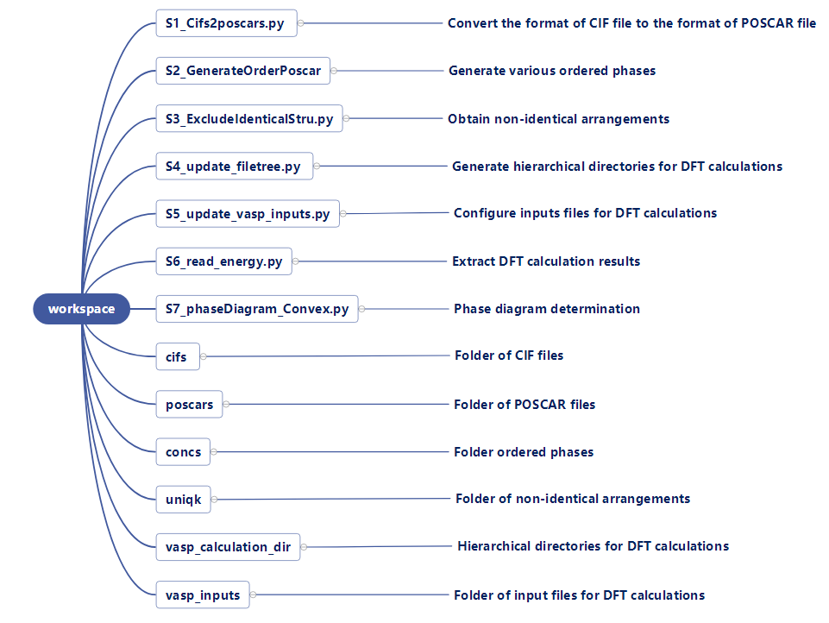

**Figure 1. Hierarchical directories of workspace for ordered ground states determinatin**

## 2 Packages required

* Matplotlib
* pymatgen
* numpy
* os
* itertools
* shutil
* re
* pandas

## 3 Introduction for each module

### 3.1 Convert the format of CIF file to the format of POSCAR file

**Module name：**

S1_Cifs2poscars.py

**Execution:**

python S1_Cifs2poscars.py

**Function：**

Read all CIF files from the folder of cifs, and then convert CIF file format to POSCAR format because VASP calculations require POSCAR as the input of structural information. POSCAR files are automatically saved to the folder of poscars.

CIF files are obtained by Bilbao Crystallographic Server. We illustrated how to obtained subgroup structures in Figure 1. In order to facilitate subsequent processing of these CIF files, the naming of CIF files shall follow the following format specifications: CIF_160t2k2_01_3a3a.cif. 160t2k2 represents subgroup 160 with *t*-index of 2 and *k* index of 2. Field of 01 is used to distinguish different conjugate classes. Field of 3a3a represents that position of Li ions are now split to 3a and 3a positions. After this convention, the name of corresponding POSCAR file will be changed to POSCAR_160t2k2_01_3a3a.

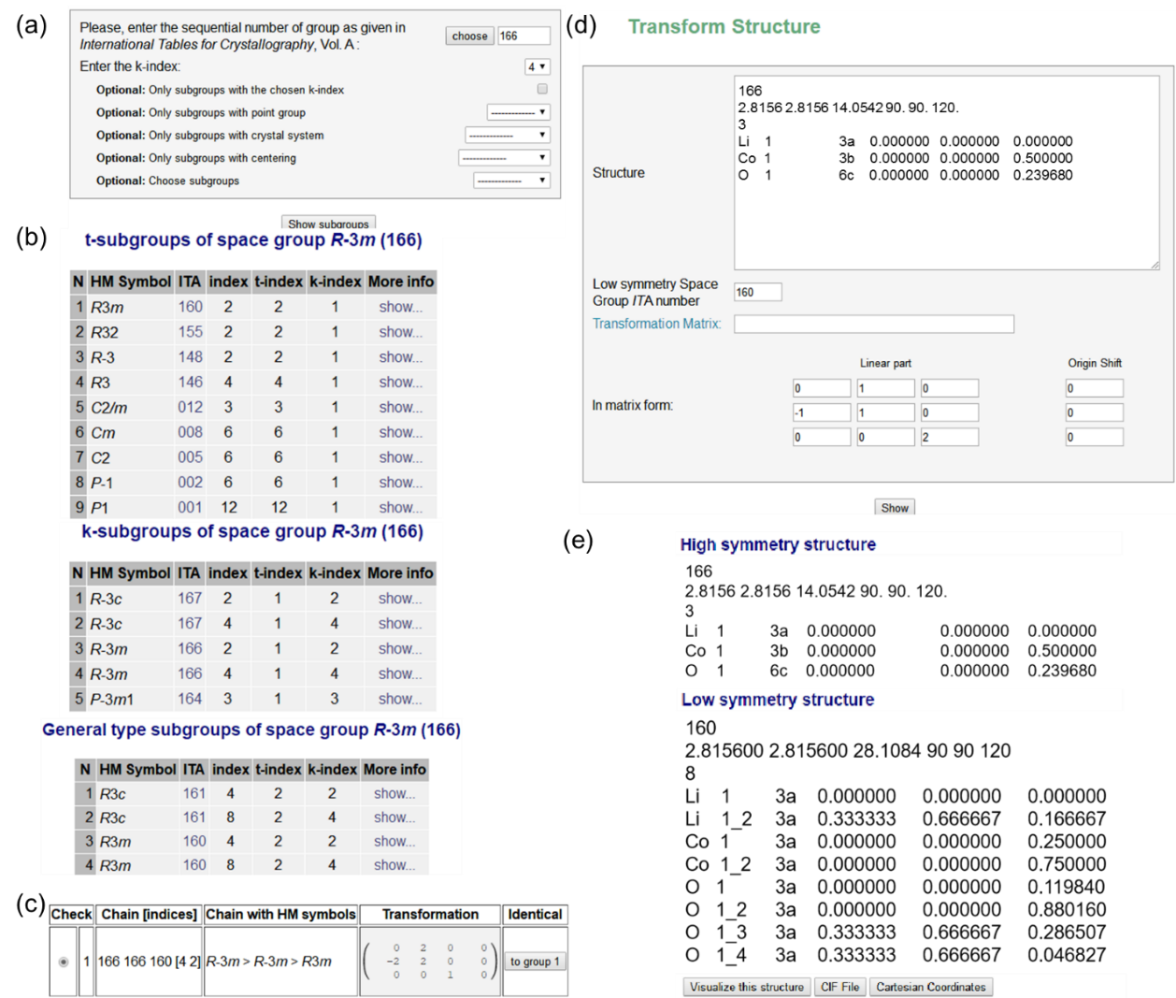

**Figure 2. An illustration of the processes that subgroup structures are obtained by Bilbao Crystallographic Server. (a) specifying parent space group, *k*-index, and crystal system in CELLSUB submodule. (b) all subgroups of the parent space group within certain *k*-index and crystal system will be listed by clicking “Show subgroups”. (c) the transformation matrix is obtained by clicking “show” for each subgroup (d) to obtain each subgroup structure in TRANSTRU submodule, transformation matrix obtained in the last step, and parent structural parameters are needed as inputs (e) structural parameters of subgroup structure (Low symmetry structure) can be obtained by clicking “Show” in the panel of the last step.**

**3.2 Generate various ordered phases**

**Module name：**

S2_GenerateOrderPoscar.py

**Execution:**

python S2_GenerateOrderPoscar.py

**Function：**

Read out all poscar files from the poscars folder. For each file, the fourth field separated by the underline of the file name records the occupancy positions of Li ions. Replacing some positions with vacancies to obtain the ordering arrangements with different Li/vacancy concentrations. In the case of ordering arrangements with ternary elements, the positions of Li need to be further divided into three categories, which are occupied by vacancy, Li and the second element respectively. For example, in LLTO, Li ions need to be occupied by Li, La and vacancy respectively. Because some positions of Li ions are replaced with vacancy or other elements, the atomic type and number recorded in the seventh line of the POSCAR file need to be updated, and the atomic coordinates occupied by vacancies should be removed. For each POSCAR file, it will generate more than one configurations with different Li concentrations and these configurations will be stored in concs folder.

inpus：

Li_La_Va = 0 0 indicates Li/vacancy order and 1 indicates Li/La/vacancy order

substi_site = “La” Replace some positions of Li ions with La, valid when Li_La_Va = 1

### 3.3 Obtain non-identical arrangements

**Module name：**

S3_ExcludeIdenticalStru.py

**Execution:**

python S3_ExcludeIdenticalStru.py

**Function：**

Read out all poscar files from the concs folder. After that, StructureMatcher utility in Pymatgen is employed to exclude identical arrangements. It compares two structures by reducing them to primitive cells and evaluating whether the maximum root means square displacement is less than a predefined tolerance cutoff. This method can effectively distinguish the non-identical structures. All non-identical structures will be write to uniqk folder.

**inputs：**

posacr files stored in concs folder

**outputs：**

non-identical structures will be write to uniqk folder.

### 3.4 Generate hierarchical directories for DFT calculations

**Module name：**

S4_update_filetree.py

**Execution:**

python S4_update_filetree.py

**Function：**

read all poscar files of non-indentical structures in uniqk folder. To simplify the hierarchy of directories, all poscar files are placed in the first level subdirectory of vasp_calculation_dir folder in parallel and sorted incrementally from 001 to facilitate quick positioning when DFT calculation stops or an error is reported.

**inputs：**

All poscar files in uniqk folder

**outputs：**

DFT calculation directory

### 3.5 Configure inputs files for DFT calculations

**Module name：**

S5_update_vasp_inputs.py

**Execution:**

python S5_update_vasp_inputs.py

**Function：**

In the hierarchical directories generated before, only POSCAR file is prepared, to implement DFT calculations, INCAR, POTCAR, KPOINTS and vasp.lsf are also needed. These files are should be prepare in advance and stored in vasp_inputs folder. After that, these files will be updated to each subdirectory if POSACR file exists there. Parameters of KPOINTS will be automatically updated according to the length of lattice.

**inputs：**

kpoints_limit K value is determined by kpoints_limit / length of lattice

### 3.6 Extract DFT calculation results

**Module name：**

S6_read_energy.py

**Execution:**

python S6_read_energy.py

**Function：**

After DFT calculations are finished, identify whether the current file is calculated successfully from the output files, and information of free energies, supercell size, Li concentration will be identified and output to a CSV file.

### 3.7 Phase diagram determination

**Module name：**S7_phaseDiagram_Convex.py

**Execution:**

python S7_phaseDiagram_Convex.py

**Function：**

The formation energy for each ordered phase is calculated, and formation energies of different systems, such as AB and AA stacking of graphite. Ordered ground states are obtained by convex hull.

**inputs：**

sys1_ready = 1 1 indicates that the formation energies of system 1 needs to be compared, otherwise this value is 0

sys1_Li1 free energy of Li1X (system 1) used to calculate formation energies.

sys1_Li0 free energy of Li0X (system 1) used to calculate formation energies.

sys2_ready = 1 1 indicates that the formation energies of system 2 needs to be compared, otherwise this value is 0

sys2_Li1 free energy of Li1X (system 2) used to calculate formation energies

sys2_Li0 free energy of Li1X (system 2) used to calculate formation energies

**outputs：**

phase diagram of AA and AB stacking graphite